# OPERATING SYSTEM - CS23431 EXP 12

**FILE ORGANISATION TECHNIQUE – SINGLE AND TWO LEVEL DIRECTORY**

**NAME: KAAVIYA.R ROLL NO: 230701504 PROGRAM:**

## Single level directory:

#include <stdio.h> struct directory{

char dname[20]; char fname[10][20]; int f_count;

};

int main()

{

struct directory d;

printf("Enter directory name: "); scanf("%s",d.dname);

printf("Enter number of files in the directory: "); scanf("%d",&d.f_count);

printf("Enter names for files:\n"); for(int i=0;i<d.f_count;i++)

{

printf("Enter name for file %d: ",i+1); scanf("%s",d.fname[i]); printf("\n\t\t%s\n",d.dname);

for (int j = 0; j <= i; j++) { printf("\t\t |\n");

printf("\t\t --> (%s)\n", d.fname[j]);

}

printf("\n");

}

return 0;

}

# OUTPUT:

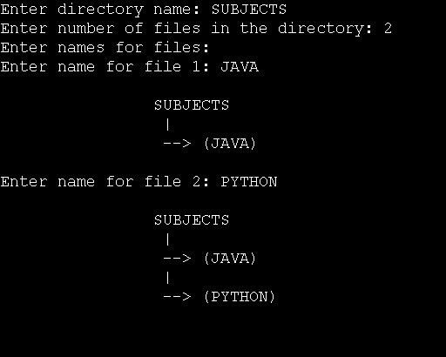

## Two level directory:

#include <stdio.h>

#include<string.h> struct directory{

char dname[20];

char subnames[10][20]; int sub_count;

};

int main()

{

struct directory d;

struct directory sub[10];

printf("Enter the name of dir/file(under null): "); scanf("%s",d.dname);

printf("How many users(for %s): ",d.dname); scanf("%d",&d.sub_count);

for(int i=0;i<d.sub_count;i++)

{

printf("Enter the name of dir/file(under %s): ",d.dname); scanf("%s",d.subnames[i]);

printf("How many users(for %s): ",d.subnames[i]); scanf("%d", &sub[i].sub_count); strcpy(sub[i].dname, d.subnames[i]);

for (int j = 0; j < sub[i].sub_count; j++) {

printf("Enter name of dir/file(under %s): ", sub[i].dname); scanf("%s", sub[i].subnames[j]);

}

}

for (int i = 0; i < d.sub_count; i++) {

for (int j = 0; j < sub[i].sub_count; j++) { printf("\t\t | %s |\n", d.dname); printf("\t\t |\n");

printf("\t\t | %s |\n", sub[i].dname); printf("\t\t |\n");

printf("\t\t ( %s )\n", sub[i].subnames[j]);

}

printf("\n");

}

return 0;

}

# OUTPUT:

